DOCUMENTATION/DATASHEET



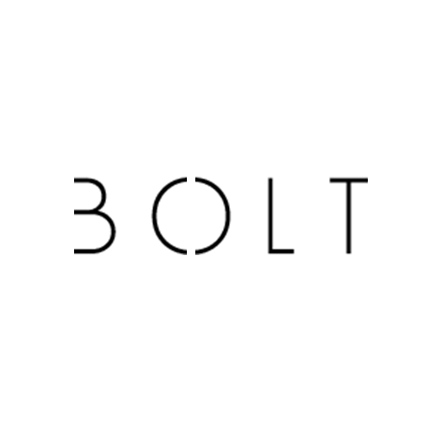

Contents

Packaging 2

Feature 3

Product summary 4

Schematics 5

Board outline 6

Board labeling 7

# Packaging

**BOLT lightMINI** **:**

* BOLT lightMINI (PCB)
* 3.5mm AUX Cable
* Schematics
* 1m of *snow white* LED Strip
* Backup *TIP31C* transistor
* Backup *680Ω resistor*
* Backup *status LED*

*NOTE : Package box may be crushed during the transport, but inside components are protected.*

# Feature

Low-power *BOLT lightMIN* LED strip controller

* 9/12V power source
* Small size PCB
* Mono and Stereo audio amplifier
* Working from -25°C to 95°C
* Compatible with all sound cards including the most popular
  + Windows Audio
  + Realtek HD Audio
  + Asus Xonar DSX PCIe 7.1
  + Asus Xonar GHX PCIe GX2.5
  + Creative Sound Blaster Audigy FX
  + Creative Sound Blaster ZxR PCIe
  + Creative Sound Blaster Z
  + Aztech AZT1008 Sound Device
  + Aztech AZT2320 Sound Device
  + Aztech AZT3000 Sound Device
  + Intel ICH2
  + Intel ICH3
  + Intel ICH4
  + Intel ICH5
  + Intel ICH6
  + Intel ICH7
  + MediaTrix AudioTrix Pro
  + MediaTrix AudioTrix 3D XG
* Passive cooling

# Product summary

|  |  |
| --- | --- |
| Features | BOLT lightMINI |
| Maximum outputs (parallel or series) | 5 short, 2 long |
| Maximum power consumption (LED) | 40W |
| Maximum load | 3A |
| Amplifier type | Bipolar N-P-N transistor |
| Maximum voltage trough transistor | 80V DC |
| Minimum voltage through PCB | 9V DC |
| Maximum voltage through PCB | 12V DC |
| Supported LED strips | White (one color)  RGB (with additional controller) |

**RGB** *LED strips* must be connected to 12V because of controller needs. If you have 9V (or less) controller, connect *BOLT lightMINI* to it’s supposed voltage.

# 

# Schematics

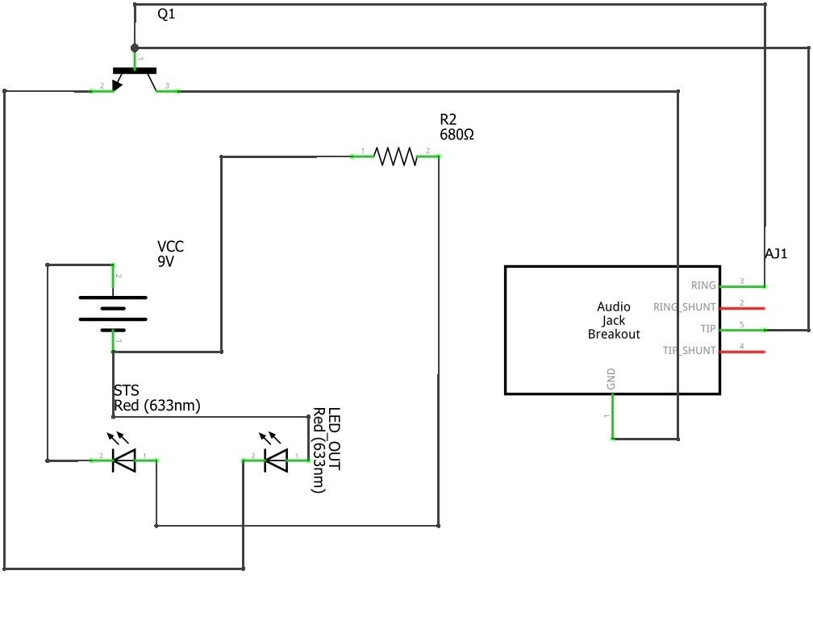

# Board outline

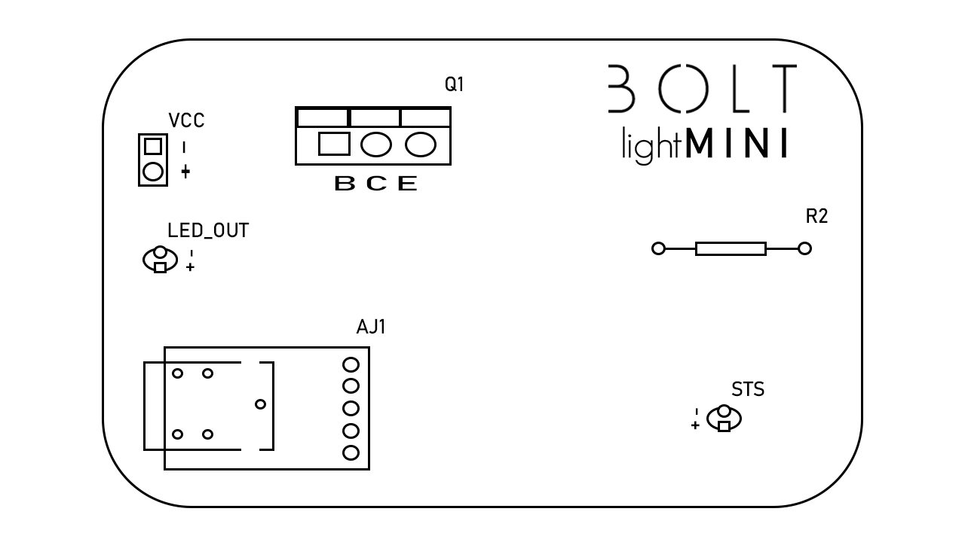

# 

# Board labeling

VCC – Input 9-12 volts DC

LED_OUT – Output for LED (output 9-12V, add resistor for LED Diode)

AJ1 – Sparkfun Audio Breakout

STS – Status 3m-m/5mm LED

R2 – 680Ω resistor

Q1 – Bipolar N-P-N TIP31C transistor

+ - | Plus (anode-positive) Minus (cathode-negative)

B C E | Base Collector Emitter

# Open source

Entire **BOLT’s** project is open-source, that means you can download PCB design, logos, covers, banners and everything from this project. You can find *BOLT* page on GitHub.

[**www.github.com/BOLTElectro**](http://www.github.com/BOLTElectro)